8.18: Take the direction of the bullet’s motion to be the positive direction. The total momentum of the bullet, rifle, and gas must be zero, so

and 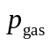= 0.866 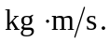Note that the speed of the bullet is found by subtracting the speed of the rifle from the speed of the bullet relative to the rifle.

